

**A PROJECT REPORT**

**ON**

# “REMOTE MONITORING OF LAB USING SMARTPHONE APPLICATION”

**SUBMITTED TO**

**SHIVAJI UNIVERSITY, KOLHAPUR**

## IN THE PARTIAL FULFILLMENT OF REQUIREMENT FOR THE AWARD OF DEGREE

**BACHELOR OF TECHNOLOGY IN INFORMATION TECHNOLOGY**

## SUBMITTED BY

**Ms. Swati Galatage 17UIT11012XX**

### Ms. Vidya Lohar 17UIT11028XX

**Ms. Rutuja Magdum 17UIT51060XX**

**Ms. Sonal Salunkhe 17UEL11086XX**

**Ms. Sayli Pote 16UIT11042XX**

**UNDER THE GUIDANCE OF**

## Prof. S. R. Patil

**DEPARTMENT OF COMPUTER SCIENCE AND ENGINEERING**

**D.K.T.E. SOCIETY’S TEXTILE AND ENGINEERING INSTITUTE, CHALKARANJI**

(An Autonomous Institute, Affiliated to Shivaji University, Kolhapur)

Accredited with 'A+' Grade by NAAC, An ISO 9001: 2015 Certified

## YEAR 2020-2021

### D.K.T.E. SOCIETY’S TEXTILE AND ENGINEERING INSTITUTE, ICHALKARANJI

(An Autonomous Institute, Affiliated to Shivaji University, Kolhapur)

Accredited with 'A+' Grade by NAAC, An ISO 9001: 2015 Certified

### DEPARTMENT OF INFORMATION TECHNOLOGY

**CERTIFICATE**

**This is to certify that, project work entitled**

# “REMOTE MONITORING OF LAB USING SMARTPHONE APPLICATION”

**is a bonafide record of project work carried out by**

**Ms.Supriya Kamble 181IT1607087**

**Ms. Swati Galatage 17UIT11012XX**

### Ms. Vidya Lohar 17UIT11028XX

**Ms. Rutuja Magdum 17UIT51060XX**

**Ms. Sonal Salunkhe 17UEL11086XX**

**Ms. Sayli Pote 16UIT11042XX**

**In the partial fulfillment of award of degree, Bachelor of Technology in Information technology prescribed by Shivaji University, Kolhapur for the academic year 2019-2020.** 

### Prof. S. R. Patil (PROJECT GUIDE)

**Prof. ( Dr.) D.V.KODAVADE Prof.(Dr.) P.V.KADOLE**

**(H.O.D. C.S.E.) (DIRECTOR)**

EXAMINER

# DECLARATION

We hereby declare that, the project work report entitled **“Remote Monitoring Of Lab Using Smartphone Application”** which is being submitted to D.K.T.E. Society’s Textile and Engineering Institute Ichalkaranji, affiliated to Shivaji University,Kolhapur is in partial fulfillment of degree B.TECH.(CSE). It is a bonafide report of the work carried out by us. The material contained in this report has not been submitted to any university or institution for the award of any degree. Further, we declare that we have not violated any of the provisions under Copyright and Piracy / Cyber / IPR Act amended from time to time.

|  |  |
| --- | --- |
|  |  |
| **PRN** **Name** | **Signature** |
| 17UIT11012XX Ms. Swati Galatage |  |
| 17UIT11028XX Ms. Vidya Lohar |  |
| 17UIT51060XX Ms. Rutuja Magdum |  |
| 17UEL11086XX Ms. Sonal Salunkhe |  |
| 16UIT11042XX Ms. Sayli Pote  181IT607087 Ms. Supriya Kamble |  |

# ACKNOWLEDGEMENT

# 

With great pleasure we wish to express our deep sense of gratitude to Mr. S. R. Patil for his valuable guidance, support and encouragement in completion of this project report.

Also, we would like to take opportunity to thank our head of department Dr.D. V. Kodavade for his co-operation in preparing this project report.

We feel gratified to record our cordial thanks to other staff members of Information Technology Department for their support, help and assistance which they extended as and when required.

Thank you,

|  |
| --- |
| 17UIT11012XX Ms. Swati Galatage |
| 17UIT11028XX Ms. Vidya Lohar |
| 17UIT51060XX Ms. Rutuja Magdum |
| 17UEL11086XX Ms. Sonal Salunkhe |
| 16UIT11042XX Ms. Sayli Pote  181IT607087 Ms. Supriya Kamble |

**ABSTRACT**

This system is used to know status of computers in lab using smartphone application. After successful login process or registration process of user , that particular user will get the status of computer. The information of lab machines stored on firebase. On one click configuration of computer will be displayed. Students can complain or send feedback. This application can help in schools, colleges and so on to check computers status.

**INDEX**

**Introduction 1**

1. **Problem Description 2** 
   1. Problem definition 2
   2. Aim and objective of the project 2
   3. Scope and limitation of the project 2
   4. Timeline of the project 3

1. **Background Study and Literature Overview 4** 
   1. Literature overview 5
   2. Investigation of current project and related work 6

1. **Requirement Analysis**

a. System requirement 8

* 1. Functional requirement 9
  2. Analysis 10

1. **System Design 11** 
   1. Architectural Design 12
   2. Data Design 13
      1. Data flow diagram 13
      2. Sequence diagram 14
      3. Activity diagram 15
      4. Deployment diagram 16
2. **Implementation 17** 
   1. Detailed Description of Method 18
   2. Methodology 22
3. **Integration and Testing 24**
4. **Performance Analysis 28**
5. **Applications 32**
6. **Installation Guide and User Manual 34**
7. **Cost Estimation 37**
8. **Ethics 38**
9. **References 41**

**Introduction**

1. **Problem definition**

To provide user friendly remote monitoring lab using smart phone application.

1. **Need of the project with motivating example**

If we want to know the status of all machines present in lab, instead of checking indivisually we can check the system with help of this application.

This application can help in schools and colleges to check status of computers.

1. **Objectives of project**

* Main purpose of this application is to save time for checking status of computer.
* This app provides user friendly monitoring of lab.
* To know about system configuration as per requirement.

1. **Scope & limitations of project**

**Scope:**

This application is help for checking status of computers in labs.

**Limitations:**

* + Internet connection required to access this application.
  + Only admin has rights to edit the status.

# Background study and Literature overview

**2. Literature Overview**

A] Technology Review**:**

* + - * **firebase:**

Firebase is a platform developed by Google for creating mobile and web applications. It was originally an independent company founded in 2011. In 2014, Google acquired the platform and it is now their flagship offering for app development.

* + - * **dart:**

Dart was released by Google in 2011 and was initially designed as a replacement for JavaScript. Since then, the release of the Flutter SDK for iOS, Android, and web development has put a new spotlight on the Dart language. The most recent version of Dart at the time of this recording is

* + - * **HTTP:**

**HTTP** is a protocol which allows the fetching of resources, such as HTML documents. It is the foundation of any data exchange on the Web and it is a client-server protocol, which means requests are initiated by the recipient, usually the Web browser.

B].Literature review (Critical appraisal of earlier work in same area):

* + The conceptual Policy Framework for computer Lab : Special( reference in University of Kelaniya Sri Lanka) P.K.G.C.Pitigala
  + The computer labs are available for University (Hartle, Mike, Lise, Simon 2012). When using computer lab users.
  + Students use mobile devices for learning and believethat technology can help them achieve learning out-comes(Chen, Seilhamer, Bennett, Bauer, 2015; Dahlstorm, 2012).

# Requirement Analysis

1. **Functional Requirements**

External interface Requirements

a) User Interface requirements

For system login user needs to login with email id and password.

1. **System Requirements:** 
   1. Operating System Requirement: windows, android
   2. Hardware requirement:

Processor: Intel ® Core™2 Due CPU E7500 @ 2.93GHz 2.93 GHz

Ram: 4/8 GB

Keyboard: optical

Monitor: 15 inch color

Mouse: optical

1. **Tools and Technologies Requirements**:

visual studio, android studio, firebase, dart,git.

**System Design:**

1]System Architecture:

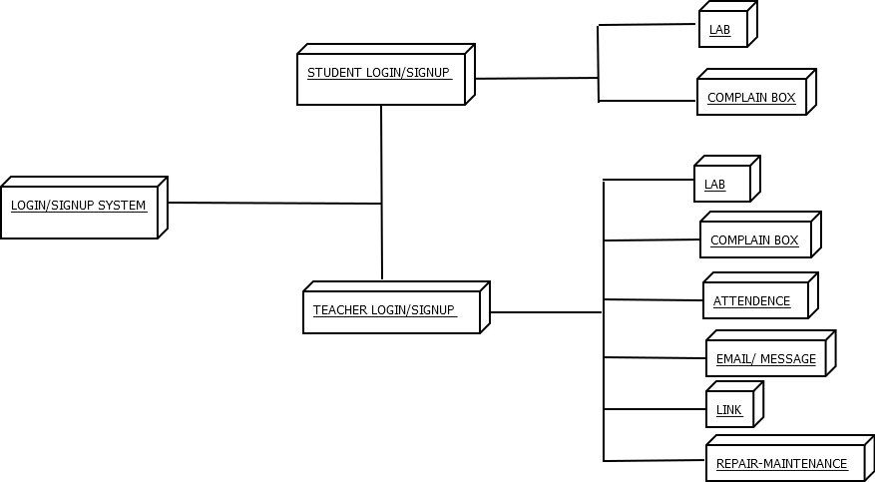

Explanation:

* To access this application you need to login or sign-up.
* Next system users teachers and students , teacher needs to register student.
* After compition of login or sign-up process dashboard will appear containing tabs such as Labs, Register,Status,Attendence,Repair & Links tabs.
* By selecting Labs or clicking on Lab ,all labs will be displayed on the screen.
* Click on machine status to check computer status , it will get displayed as pop-up message.
* Teachers can send mail or message to parents or student. Also manage repair and maintainace.

**2]User Interface Design:**

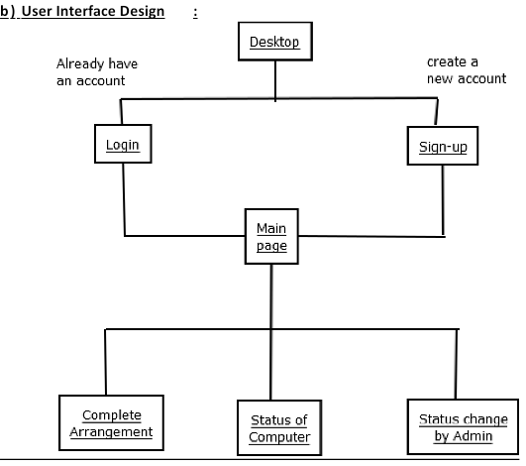

Explanation:

To enter in Lab monitoring system we have two options login and signup  for login -user have already account in system. user can create new account in system by entering name password mobile number etc.

Then main page get displayed containg following tabs:

1. Labs

2. Resister

3. Status

4. Attendance

5. Repair

6.  Links

C] Algorithmic description of each modules:

**Module1: Login/sign up page**

Input: email and password

Output: successfully formentry

Description: It will take only valid email and password

**Module2: Dashboard**

Input: none

Output: It will display list of labs.

Description: click on lab you want.

**Module 3: computer arrangement**

Input: none

Output: It will display arrangement of computers

Description: click on computer you want to check

**Module 4: Status of computer**

Input: none

Output: It will display system configuration and installed application.

Description:We can get actual information of status here.

**Module5: Complaint box**

Input **:** students add complain

Output**:** complain send

**3] System Modeling**

1] Dataflow Diagram:

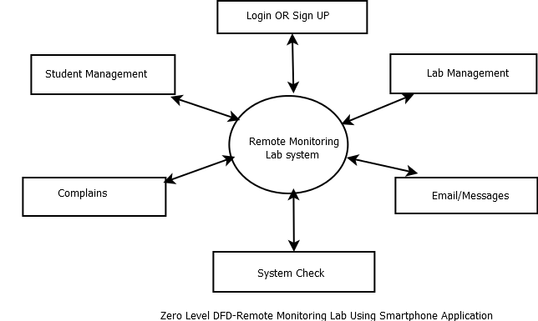

Explanation:

User can login into system using email and password. Dashboard will get displayed using different tabs. The tabs are lab, register,complain,links,status etc. when we click on labs tab information related labs get displayed along with computers status information.The system also contains complain box regarding any complaint.

4] Collaboration Diagram :

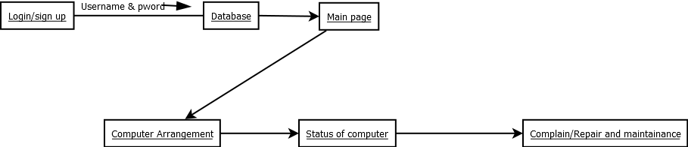

Explanation:

In this first user (teacher or student) login into system using valid email id and password. After that the information goes to database to check if given email id and password valid or not , if its valid it gives access to main page. In main page we can see different tabs such as labs,complain etc. Next in labs section we can choose different types of lab associated in college and after selecting particular lab such as Machine Learning lab we can see the different computers and their status.

5.Sequence Diagram :

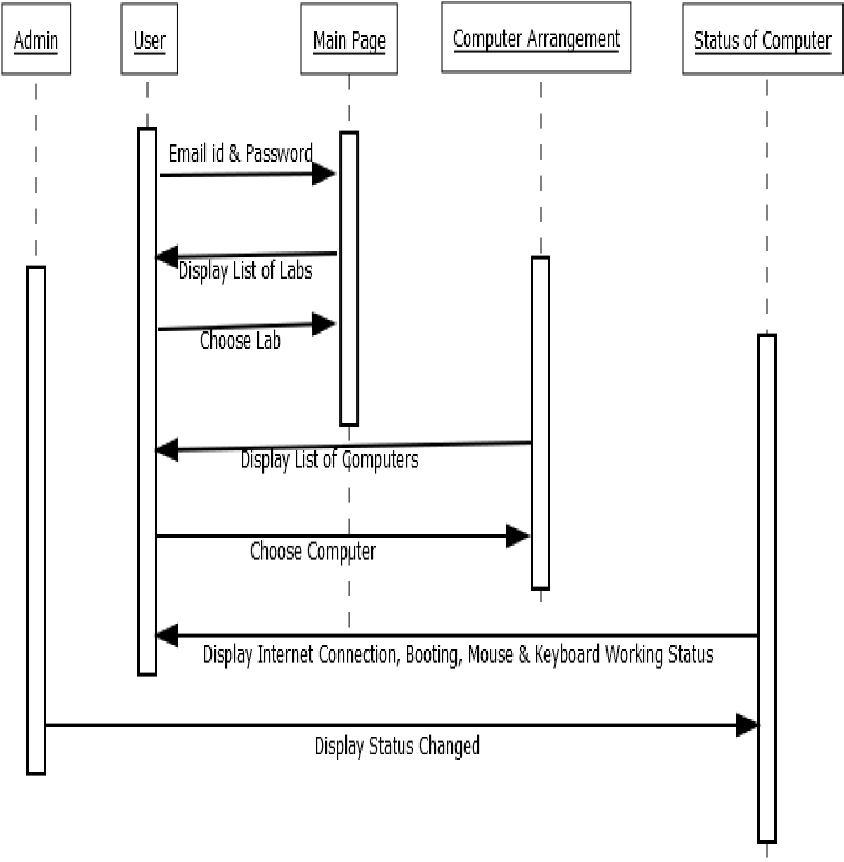

Explanation:

In sequence diagram User  Computer arrangement and Status of computer are included

* First User enter email id and password and enter into system
* After successfully login into system user can choose computer from displayed computer arrangement and by clicking that computer display status of that computer

1. User case Diagram :

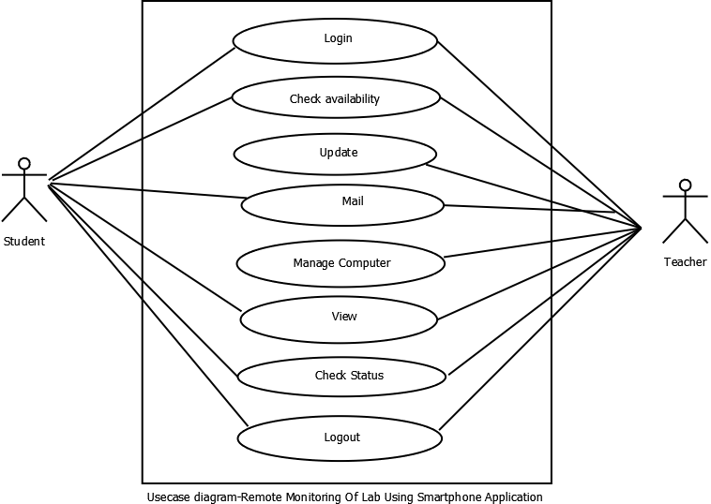

Explanation:

In this use case diagram the main actors are teacher and student.Teacher have authorities like login, check availabaility , upadate information, mail, manage computers in labs, view the system, check status of computers in labs, complain etc. On the other hand student can login into system, check availability of computers, mail, view the system, check status of computers and logout.

4.Activity diagram:

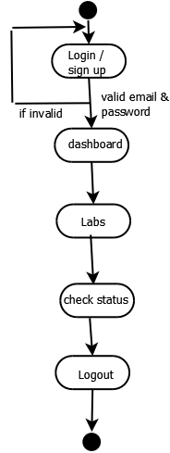

Explanation:

In this activity diagram login is initial point and logout is final point.First User enter email id and password and enter into system After successfully login into system user can choose computer from displayed computer arrangement and by clicking that computer display status of that computer.

**e] Database Design**

1. ER design :

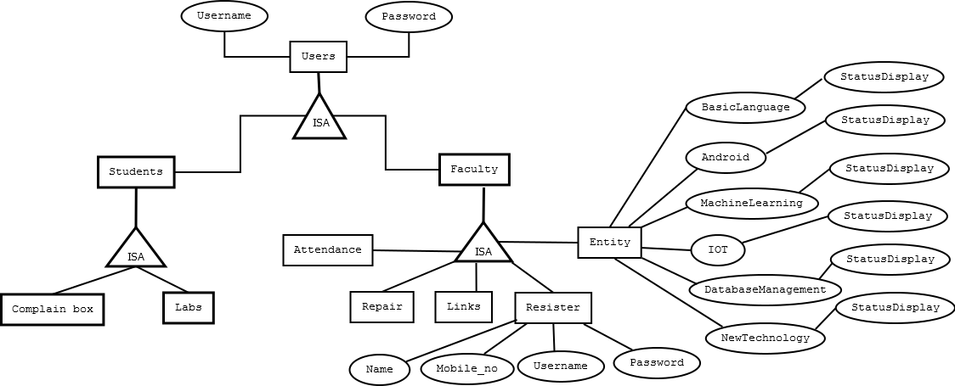

Explanation:

In this Entity relation diagram the main entities are teachers,students and system and there corresponding attributes. Teachers have attributes like id, name, password,department etc. while student has attributes like name, id, email, password, department, class etc.The student and teachers are directly related to system .

5**.IMPLEMENTATION**

**1.Flutter:**



Flutter is an open source framework to create high quality, high performance mobile applications across mobile operating systems - Android and iOS. To extend the capabilities of application.

**2.Dart:** 

To provide a simple, powerful, efficient and easy to understand SDK to write mobile application in Google’s own language, *Dart*.Using this language we have created pages.

**3.Firebase:**

For database management we are using firebase. Firebase is a platform developed by Google for creating mobile and web applications.

**4.HTTP:**

Hypertext Transfer Protocol (**HTTP**) is an application-layer protocol for transmitting hypermedia documents, such as HTML. It was designed for communication between web browsers and web servers, but it can also be used for other purposes

**6.Implementation And Testing:**

|  |  |  |  |  |  |
| --- | --- | --- | --- | --- | --- |
| Test case No. | Test Case | Input | Expected output | Actual Output | Status |
| 1 | Login | Email/password | Main page  display | Main page display | Pass |
| 2 | Register | Name, mbl no, username, pass | Sign up | Sign up | Pass |
| 3 | Labs dashboard | Chose machine | Display  configuration | Display  configuration | Pass |
| 4 | complains | Add complain | Sent email or sms | Sent email or sms | Pass |

**Integration Testing:**

|  |  |  |  |  |  |
| --- | --- | --- | --- | --- | --- |
| Test case No. | Test Case | Input | Expected output | Actual Output | Status |
| 1 | Lab 1 | Machine 2 | Display  configuration | Display  configuration | Pass |
| 2 | Lab 2 | Machine 5 | Display  configuration | Display  configuration | Pass |

|  |  |
| --- | --- |
|  |  |

**7. REFERENCE**

* International Research Journal of Engineering and Technology (IRJET) [www.irjet.net](http://www.irjet.net/)
* IEEE Transaction paper on Addressing the Bandwidth Efficiency, Control, and Evaluation Issues in Software Remote Laboratory.
* O. A. Herrera, G. R. Alves, D. Fuller, and R. G. Aldunate, “Remote lab experiments
* Github.com
* Google

* ing possibilities for distance learning in engineering fields,” in IFIP World Computer Con-

a